# Initial Center Setup

1. Copy the contents of the dispatch_centers/dispatch_template directory into your local center directory on the NIFC web server. You may want to create a directory like new within your center’s folder while you work on building the new website.



1. Edit the dispatch_config.php file to set the information for your center’s name, Unit ID, address, email, and phone numbers.

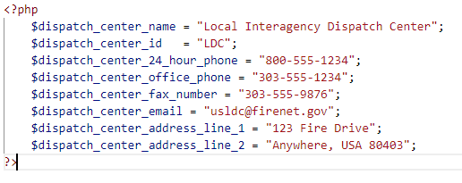

1. Edit the sidebar following the instructions for links or menus
2. Add any main contents to the index.php replacing ‘<!-- Enter home page content here -->’ with your content

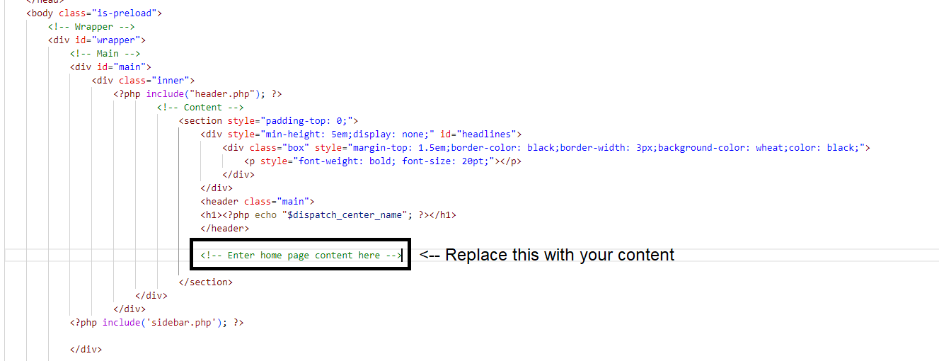

1. Add additional pages to support your center’s needs using the following instructions for list of links or image tiles

# Configure Sidebar Link – Link Only

1. Open the sidebar.php file
2. Paste the following line between the Sidebar section start and end comments replacing ‘<!-- Additional Sidebar Content Goes Here -->’

<li><a href="Enter URL to page">Enter Link Text for Page</a></li>

1. Replace the URL and the display text for the link.

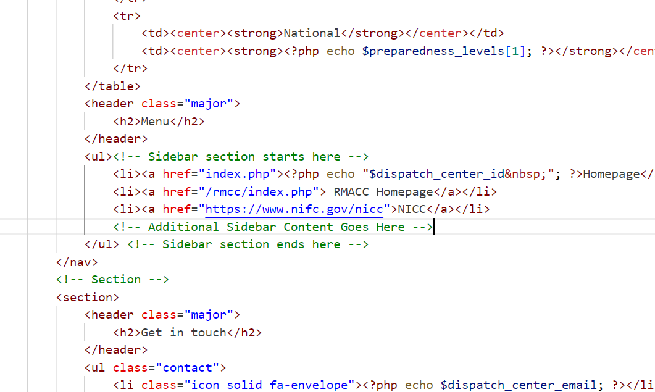

# Configure Sidebar Link – Menu

1. Open the sidebar.php file
2. Copy the following lines between the Sidebar section start and end comments where you like the menu to go, replacing ‘<!-- Additional Sidebar Content Goes Here -->’

<li>

<span class="opener">Enter Section Name Here</span>

<ul> <!-- Begin submenu list -->

<!-- Additional Links Go Here -->

</ul> <!-- End submenu list -->

</li>



1. Edit the Section Menu Name
2. You can have as many links as you want, just copy the following line between the Begin and end submenu list comments, replacing ‘<!-- Additional Links Go Here -->’

<li><a href="Enter URL to Page">Enter Link Text for Page</a></li>

1. Edit the URL and display text for the link

# Create New Page – List of Links

1. Copy the list_template.php to a new file for the new page.
2. Edit the page title on line 3.
3. For each subsection of link you would like you will need to enter the subsection heading and then add the links
4. To add a link copy the following line between the begin and end link list comments, making sure to edit the URL and display text

<li><a href="Enter URL to page">Enter Link Text for Page</a></li>

1. You can have as many subsections as you would like, just copy the following lines between the begin and end page subsections comments and configure using the above 2 steps for each

<section>

<h3 class="heading">Enter Subection heading</h3>

<div class="padded">

<ul> <!-- Begin link list -->

<li><a href="Enter URL to page">Enter Link Text for Page</a></li>

</ul> <!-- End link list -->

</div>

</section>

# Create New Page – Image Tiles

1. Copy the image_tile_template.php to a new file for the new page.
2. Edit the page title on line 3.
3. For each subsection of tiles you would like you will need to enter the subsection heading and then tiles
4. To add a tile, copy the following line between the begin and end tile list comments, making sure to edit the URL for the link, the URL for the image, and a description of the image

<div class="col-3">

<span class="image fit" style="text-align: center; font-weight:bold; color:black;">

<a href="Enter Link URL" target="_blank"><img src="images/TileTemplate.png" alt="Enter Image Description" /></a>

</span>

</div>

**Note: To keep the tiles useable on a mobile device, limit each row to no more than 4 tiles, for additional tiles see step 5.**

1. To add additional rows to a subsection, copy the following lines between the begin and end subsection rows comments, adding up to 4 additional tiles to the subsection per row

<br /><br />

<div class="row gtr-50 gtr-uniform">

<!-- Begin Tile list -->

<div class="col-3">

<span class="image fit" style="text-align: center; font-weight:bold; color:black;">

<a href="Enter Link URL" target="_blank"><img src="images/TileTemplate.png" alt="Enter Image Description" /></a>

</span>

</div>

<!-- End Tile list -->

</div>

1. To add additional subsections to the page, copy the following lines between the begin and end page subsections comments, editing them using step 3 to 5 as needed

<section style="width:100%;">

<h3 class="heading" style="text-align: center;">Enter Subsection Title</h3>

<div class="box alt" style="margin: 10px;">

<!-- Begin subection rows -->

<div class="row gtr-50 gtr-uniform">

<!-- Begin Tile list -->

<div class="col-3">

<span class="image fit" style="text-align: center; font-weight:bold; color:black;">

<a href="Enter Link URL" target="_blank"><img src="images/TileTemplate.png" alt="Enter Image Description" /></a>

</span>

</div>

<!-- End Tile list -->

</div>

<!-- End subection rows -->

</div>

</section>